**22510064**

**PARSHWA HERWADE**

**FINAL YEAR CSE 2025-26  
  
GITHUB LINK FOR DETAILS:  
https://github.com/parshwa913/Parshwa-s-Online-Bookstore**

**Figma Prototype Link:**

https://www.figma.com/design/fziMoYTwSlNqwkxsAHaUqY/Parshwa-s-Online-Bookstore?node-id=0-1&t=PZKn9xrA7epjRbSz-1

**Video Walkthrough Link:**

https://drive.google.com/file/d/1sbKSNWjuvjq4qIeAr7xRaCtl996zChnT/view?usp=sharing

**ISE-1 – Prototyping User Interfaces Using Figma**

**Course:** Human–Computer Interaction (HCI)  
**Project Title:** Online Bookstore Mobile Application

**Part 1: Research & User Requirements**

**User Personas**

**Persona 1 – Mike Ross**

* **Age:** 21, College Student
* **Background:** Lives in Mumbai, regularly buys academic books online.
* **Goals:** Quickly find and purchase textbooks and novels.
* **Frustrations:** Confusing navigation, hidden prices.
* **Motivation:** Wants a simple app where he can log in, search, and buy books without distractions.

**Persona 2 – Harvey Specter**

* **Age:** 28, Corporate Professional
* **Background:** Works in a multinational company, reads during commutes.
* **Goals:** Browse new releases and purchase them quickly.
* **Frustrations:** Slow checkout process, cluttered homepages.
* **Motivation:** A clean, fast experience with fewer steps from browsing to checkout.

**Persona 3 – Louis Litt**

* **Age:** 35, IT Engineer & Avid Reader
* **Background:** Reads across genres, prefers curated book lists.
* **Goals:** Explore books by genre and buy instantly.
* **Frustrations:** Poor categorization and lack of sorting options.
* **Motivation:** A visually organized app with clear genre sections.

**User Stories**

1. As a student, I want to search for books by category so that I can find my textbooks quickly.
2. As a professional, I want a fast checkout so that I can complete a purchase during short breaks.
3. As a reader, I want visible ratings and prices so that I can make quick buying decisions.

**User Scenarios**

1. Mike logs in, searches for a programming book, views its details, adds it to the cart, and completes the purchase via UPI.
2. Louis opens the app, browses featured books, selects a romance novel, and places a cash-on-delivery order.

**Functional Requirements**

1. Secure login and registration.
2. Category-based browsing.
3. Book detail view (title, author, price, ratings, description).
4. Add to cart and view cart contents.
5. Multiple payment methods (VISA, COD, Mastercard, Stripe).

**Non-functional Requirements**

1. Clean, minimal design for better focus.
2. Load screens in under 3 seconds.
3. Mobile-optimized layout.
4. High-contrast, readable typography.

**Part 2: Wireframing (Low Fidelity)**

Six low-fidelity grayscale screens were created in Figma to represent the structure and flow before adding visual details.  
These screens match the final app flow:

1. **Login Screen:** Email & password fields, “Login” button.
2. **Home Screen:** Search bar at the top, category list, featured books grid.
3. **Genre Screen:** 2-column grid of books filtered by selected genre.
4. **Book Details:** Large cover image, title, author, price, description, “Add to Cart” button.
5. **Cart Screen:** Book list with prices, total amount, “Checkout” button.
6. **Checkout Screen:** Payment methods (VISA, COD, Mastercard, Stripe).

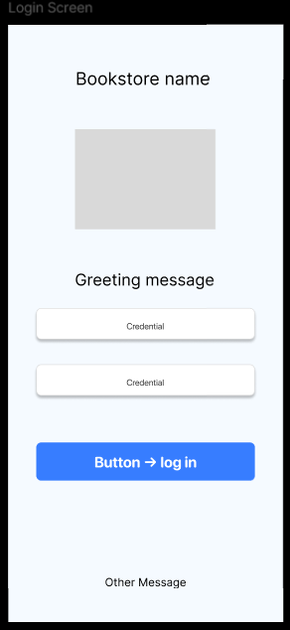

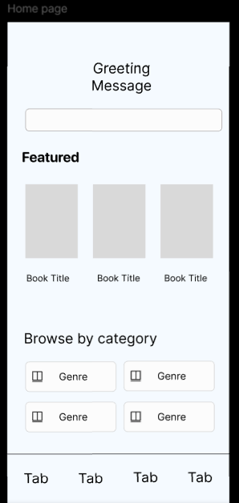

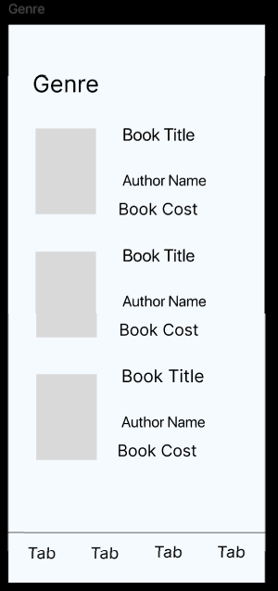

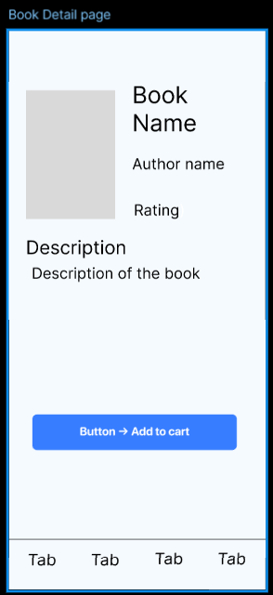

**Part 3: High-Fidelity Prototype**

The high-fidelity version was designed using the following visual and interaction choices:

**Colour Scheme:**

* White background for clarity.
* Bright blue buttons for primary actions.
* Black text for strong readability.

**Typography:**

* Clear SF ROUNDED font for modern, easy reading.
* Bold titles for book names.

**Navigation:**

* Bottom navigation bar with icons.
* Tappable book covers and buttons.

**Screen Flow:**

1. **Login →** Home Screen.
2. **Home →** Genre or Featured section.
3. **Genre →** Book Details.
4. **Book Details →** Add to Cart → Cart Screen.
5. **Cart →** Checkout.
6. **Checkout →** Order Success page with confirmation message.

The prototype was fully linked in **Figma Prototype Mode**, enabling click-through navigation from login to order confirmation.

  
  
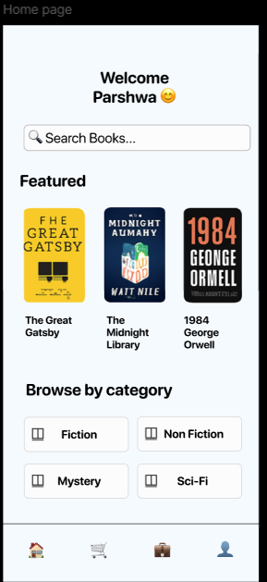

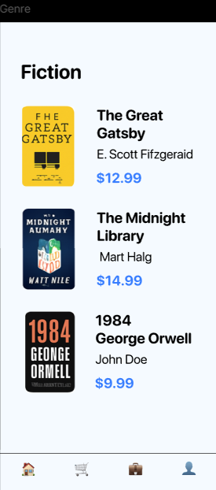

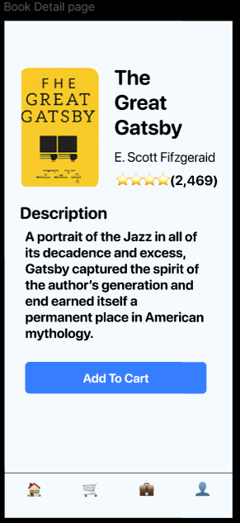

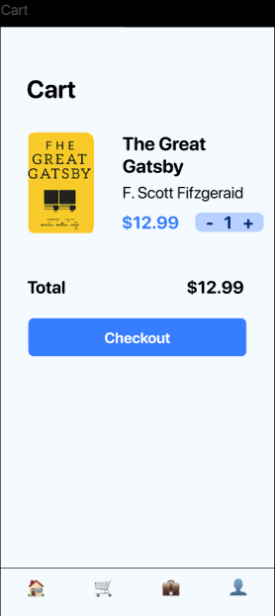

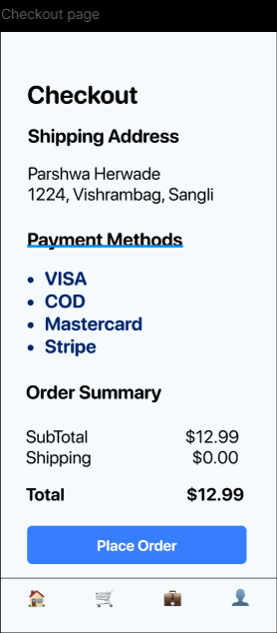

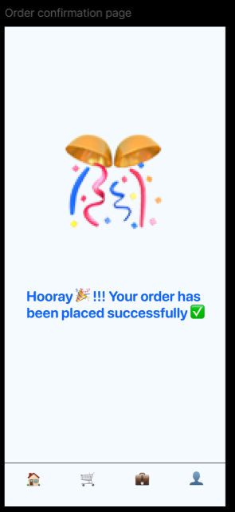

**Part 4: Usability Considerations**

**Consistency:**

* All buttons have the same style, colour, and rounded corners.
* Same header layout across all screens.

**Feedback:**

* “Order Successful” screen confirms completion.
* Buttons change colour on tap to show interaction.

**Visibility:**

* Prices, book titles, and action buttons are always visible without scrolling.

**Accessibility:**

* High colour contrast between background and text.
* Large tap targets for mobile users.

**Post-feedback changes:**

* Moved “Add to Cart” button higher on Book Details screen for easier reach.
* Enlarged book cover thumbnails for better browsing.

**Part 5: Submission & Presentation**

**Report Includes:**

* Detailed documentation of design process.
* Screenshots of wireframes and high-fidelity prototype (to be attached in the appropriate sections).
* Justification of design choices (explained above).
* Reflection on usability.

The final prototype achieved the goal of a **simple, fast, and visually clean** online bookstore app. User testing confirmed that navigation is intuitive, and checkout is straightforward. The design can be improved further by adding wishlist functionality and sorting filters for book lists.

